
Invitation for Thursday, 12th of March NZISF seminar (on ZOOM)

Seminar topic: New Zealand Security Threat Environment Report 2025
The New Zealand Security Intelligence Service (NZSIS) is the country’s lead agency for security intelligence. Its mission is to keep New Zealand safe and secure by staying ahead of the threats we face by working to counter violent extremism, terrorism, foreign interference and espionage, and insider threat. Operating under Intelligence and Security Act 2017, the NZSIS gathers and analyses intelligence to inform government decision-making and support our national security.
This presentation will cover the key assessments made in the New Zealand Security Threat Environment Report 2025 and highlight the range of advice available to support good protective security practices.

Presenter: Toni Butler
Toni is the Engagement Unit Manager at NZSIS
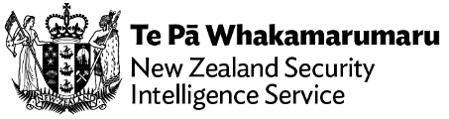



Details for registration:
- Registration fee: $10.00.
- Registrations will be accepted until the morning of Wednesday, 11th of March.
- ZOOM login will be circulated to attenders on Wednesday, 11th of March.




To place your name on the NZISF mailing list, click here
To remove your name from the NZISF mailing list, click here

Lech Janczewski
NZISF Chair

